DRV8838 Single Brushed DC Motor Driver Carrier (<https://www.pololu.com/product/2990>)

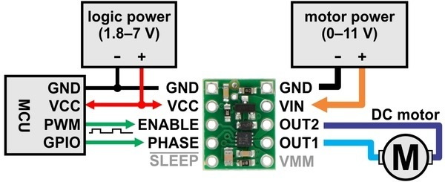

RPI-3 header pin

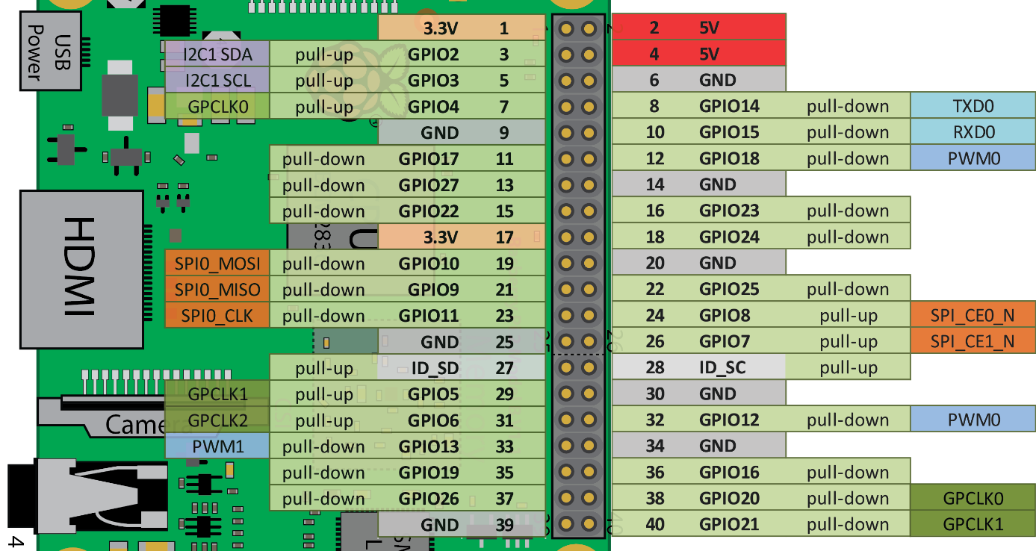

Filter is required. Just using this driver gives motion blur.